MongoDB Assignment 1

- Create a new database called student_management.

QUERY— use student_management

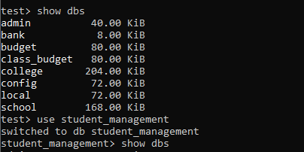

- Create a collection called students in the student_management database.

QUERY—db.createCollection(“student”)

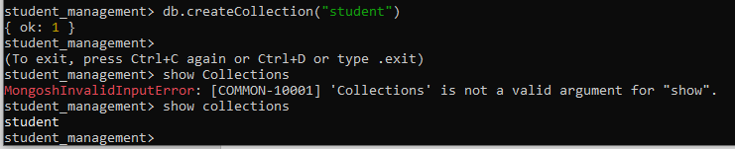

- Insert at least five student records into the students collection. Each record should have the following fields:
- student_id (integer)
- name (string)
- age (integer)
- department (string)
- courses (array of strings)
- grade (string)
QUERY—
db.student.insertMany([{student_id:101,
name:"Akshay Kumar",
age:23,
department:"BCA",
courses:["C++","Python"],
grade:"A"
},
{student_id:102,
name:"salman khan",
age:24,
department:"Btech",
courses:["HTML","PHP"],
grade:"B"
},
{student_id:103,
name:"Shahid kapoor",
age:20,
department:"BSc",
courses:["HTML","Python","Javascript"],
grade:"C"
},
{student_id:104,
name:"John abraham",
age:19,
department:"BCA",
courses:["Javascript","HTML","AsP.net"],
grade:"D"
},
{student_id:105,
name:"Amir khan",
age:24,
department:"Btech",
courses:["Javascript","HTML"],
grade:"B"
}
])
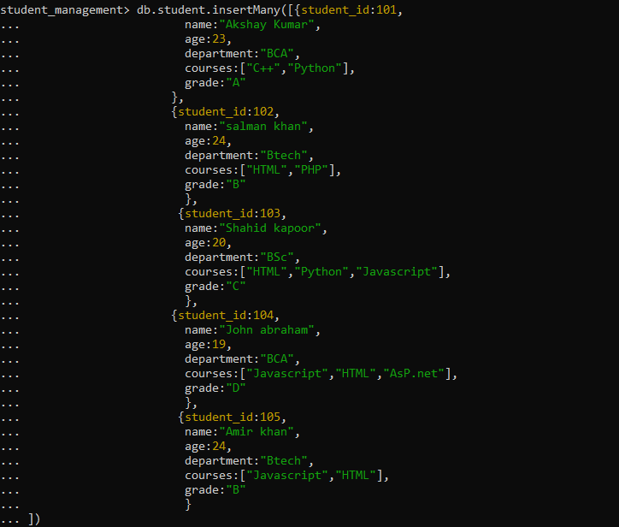
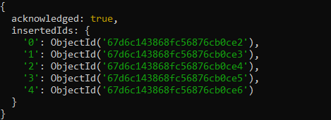

# after db.student.find()
We get,
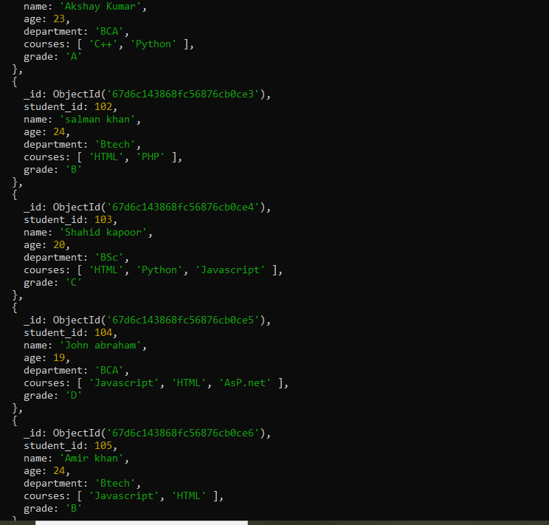
- Query the Collection:
Write queries to perform the following tasks:
- Retrieve all students who are in the "Computer Science" department.

QUERY—
db.student.find({department:"Btech"})
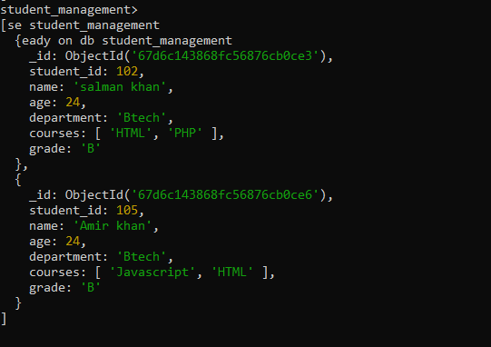

- Retrieve students who have an age greater than 21.

QUERY—
db.student.find({age:{$gt:21}})

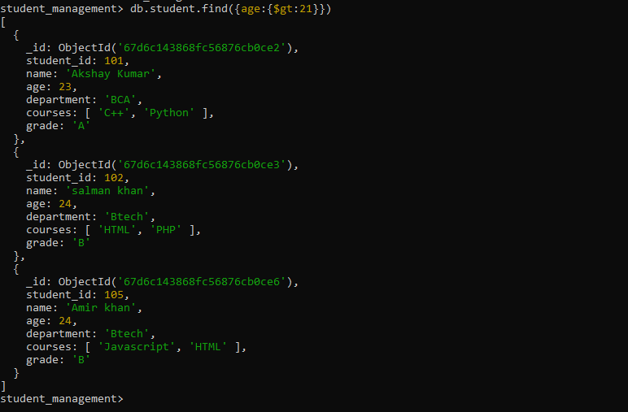

- Retrieve students who are taking the "Database Systems" course.

QUERY—
db.student.find({courses:"HTML"})

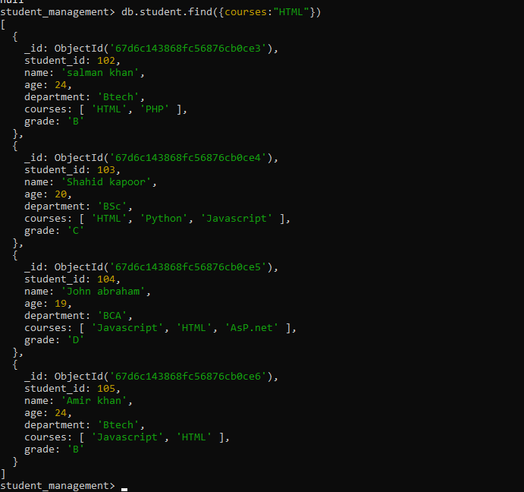

- Retrieve students with a grade of "A".
QUERY—
db.student.find({grade:"A"})
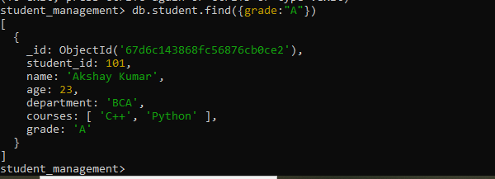

- Update Documents:
- Update the age of a student with student_id 101 to 21.
QUERY—
db.student.updateOne({student_id:101},
{$set:{student_id:21}}
)
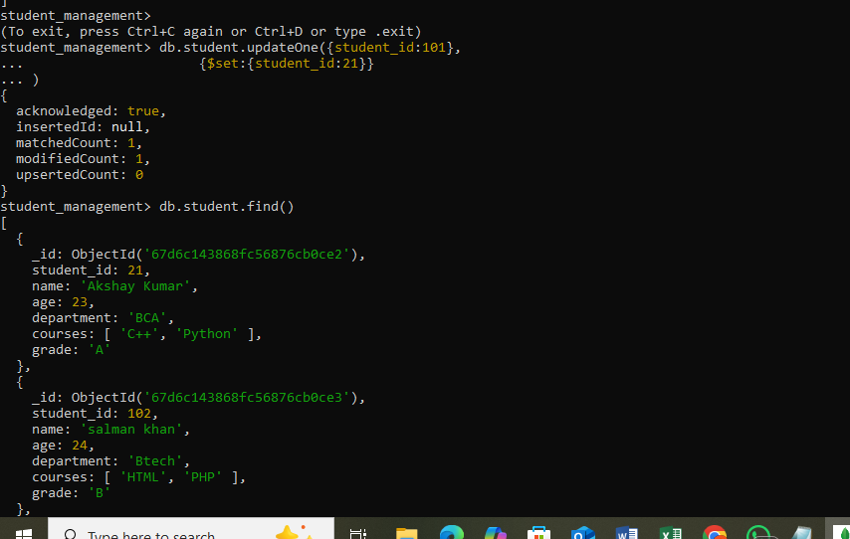

- Add a new course, "Machine Learning", to the courses array for students in the "Computer Science" department.

QUERY—
db.student.updateMany(
{ department: "Btech" },
{ $addToSet: { courses: "Machine Learning" } }
);
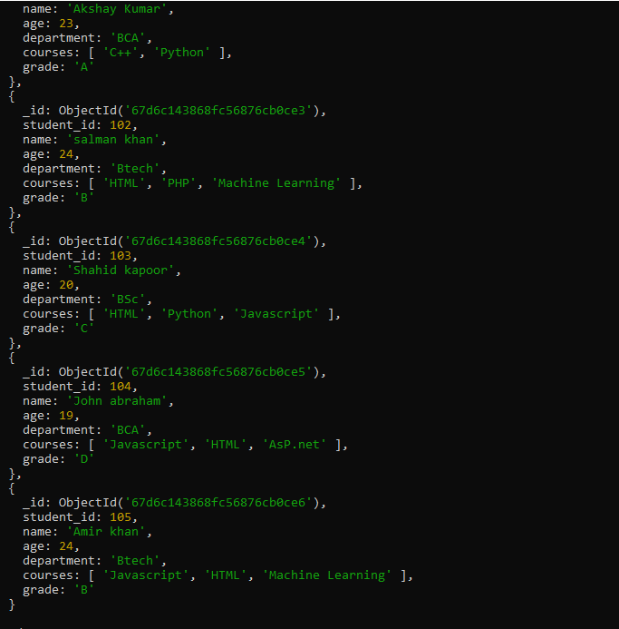

- Delete Documents:
- Delete a student record with student_id 105.
QUERY—
db.student.deleteOne({student_id:105})
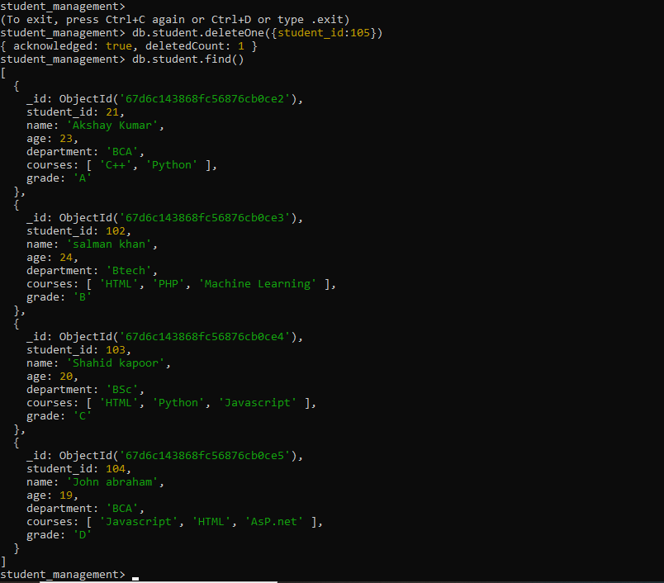

- Delete all students who have a grade lower than "C".
QUERY—
db.student.find({grade:{$lt:"C"}})
